New Patient Intake Form

Name:________________________ Date:________________

Date of Birth:___________ Age:____ E-mail:_______________

Address:____________________________ City/State/Zip code______________________________

Home number:___________________ Work:_______________ Cell:__________________________

Occupation:_________________ Marital Status:__________________ Allergies:_________________

Height:_________ Weight:__________

Emergency Contact Name:________________ Phone:_________________

Relationship:______________

Physician (Name)_________________________ (Phone)_________________

*General Questions*

Have you had Acupuncture before?___ Yes__No

Chief Complaint:_________________________

How long have you had this condition?________________________

Is it getting worse?_ ___________________

Does it bother your:___ Sleep____ Work__ Other

What seem to be the initial cause? _________________________

What seems to make it better? _______________

What seems to make it worse? ______________

Are you experiencing pain right now? ____________

Describe the pain: _____Dull _____Sharp _______Stabbing _______Shooting _______Burning ______Other

Which of the following helps: ____Heat ____ Pressure ____Movement ____Cold _____Massage

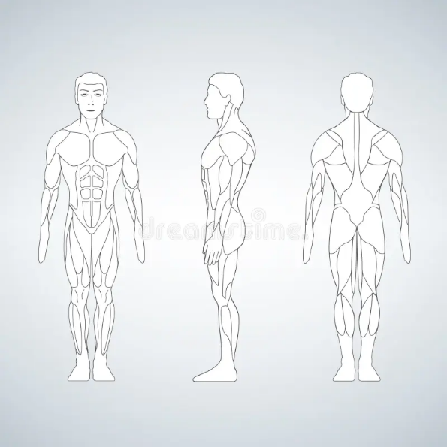

PLEASE MARK YOUR AREA OF PAIN

*Family Medical History*

* ____Arteriosclerosis
* ____Alcoholism
* ____Cancer
* ____Diabetes
* ____High Blood Pressure
* ____Seizures
* ____Asthma
* ____Stroke
* ____Heart Disease
* ____Other

Are you currently on any medications? __ No__ Yes If Yes, please list:________________

Do you take any vitamins or supplements? ___No ___Yes If Yes, please list:____________

*Lifestyle*

Alcohol use: ___Yes ___No If Yes, how often____________

Tabacco use: ___Yes ___ No If Yes, how often_____________

Stress: ___Yes ___ No If Yes, where on a scale of 1 – 10________

Marijuana:___________

Drugs:_______________

Occupational Hazards:____________

Regular Exercise: __________ How often:______ Type of Exercise:____________

Acupuncture confidential health history

Patient Name __________________

Date______________

The items below may relate to your current conditions. In the space in front of each item, place a H if you previously HAD the problem. Place P if you PRESENTLY have the problem. Leave space blank if you NEVER had the problem.

General

o ____Fever/Chills

o ____Night Sweats

o ____ Spontaneous Sweat

o ____Loss of Sleep

o ____Fatigue

o ____Nervousness

o ____Weight Loss/Gain

o ____Allergies

o ____Bleeding

o ____Diabetes

o ____Thyroid disease

o ____Cancer

o ____HIV risk factors

o ____Cold or Warm extremities

HEENT

Ear

o ____Ringing

o ____Hearing loss

o ____Itching/Pain

o ____Other

Eye

o ____Dryness

o _____Redness

o ____Itching/Pain

o ____Burning

o ____Blurred Vision

o ____Tearing

o ____Other

Nose

o ____Bleeding

o ____Congestion

o ____Clear Running Nose

o ____Ulcerations

o ____Sinus Infection

o ____Loss of Smell

o ____Other

Mouth

o ____Dryness

o ____Abnormal Taste

o ____Sore/Pain

o ____Ulcerations

o ____Bleeding Gums

o ____Bad Taste in Mouth

o ____Dental Problems

o ____Other

Throat

o ____Dryness

o ____Itching/Soreness/Pain

o ____Swelling

o ____Difficulty Swallowing

o ____Hoarseness

o ____Tonsillectomy

Chest

o ____Congestion

o ____Pain

o ____Warm/Heat sensation

o ____Other

Breast

o ____Pulling sensation

o ____Pain

o ____Distention in part

o ____Nodule

o ____Discharge

Epigastric Area

o ____Pain

o ____Pulling sensation

o ____Warm/Heat

o ____Cold

LUNG/ RESPIRATORY

o ____Difficulty Breathing

o ____Shortness of Breath

o ____Cough

o ____Chronic Cough

o ____Spitting Phlegm

o ____Wheezing Asthma

o ____Pneumonia

o ____Bronchitis

o ____Tuberculosis

o ____Lack of Perspiration

o ____Excessive Perspiration

o ____Other

HEART/ CARDIOVASCULAR

o ____Irregular Heartbeat

o ____High Blood Pressure

o ____Low Blood Pressure

o ____Pain Over Heart

o ____Palpitations

o ____Poor Circulation

o ____Dizziness

o ____Fainting

o ____Heart Disease History

o ____Swelling Ankles

o ____Varicose Veins

o ____Rheumatic Fever

o ____Stroke

o ____Other

SP/ST/LV GASTROINTESTINAL

Abdomen

o ____Swollen

o ____Distention or Gas

o ____Pain

o ____Belching

o ____Stinging

o ____Coldness

o ____Constriction

o ____Cramping

o ____Pulling Down Sensation

o ____Poor Appetite

o ____Excessive Appetite

o ____Poor Digestion

o ____Nausea

o ____Vomiting

o ____Vomiting Blood

o ____Acid Regurgitation

o ____Black/ Bloody Stool

o ____Ulcer

o ____Hernia

o Frequency of bowel movements

Everyday_____Day(s)____Time(s)

o ____Diarrhea

o ____Loose Stools

o ____Constipation

o ____Hemorrhoids

o ____Appendicitis

Liver

o ____Liver disease

o ____Jaundice

o ____Hypochondriac pain

o ____Other

List Dates and Reasons for Hospitalizations / Surgeries: __________________________________________________________________________________________________________________________________________________________________________________________________________________

Current Medications (including name, dose, frequency, and reason): __________________________________________________________________________________________________________________________________________________________________________________________________________________

Current Physician Name:___________________ Date Last Seen: ___________

I agree that the information I provided on this intake is true. It is my responsibility to inform the Acupuncturist at any point of my course of treatment if any information has changes.

Signature of Patient: __________________

Date: ________________